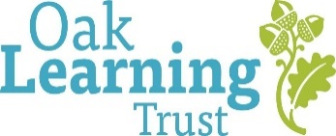
Person Specification: Cleaner
Area | Criteria
 | Essential | Desirable
Qualifications | - Willingness to attend relevant training (e.g. COSHH, Health & Safety), Effective cleaning
Experience & Knowledge |  | - Experience in cleaning in a workplace, public building, or similar setting  - Knowledge of Health and Safety in the work place.  - Knowledge of COSHH.
Skills and Aptitude | - Ability to use a range of cleaning equipment and materials safely  - Awareness of COSHH and general Health & Safety procedures or willing to undertake training  - Manual Handling experience and training or willing to undertake training  - Ability to follow instructions and work independently without supervision  - Ability to manage time and workload efficiently  - Good attention to detail and pride in maintaining high standards of cleanliness  - Able to work as part of a cleaning team with strong focus on shared accountability, cleanliness and presentation
Commitment and attributes | - Flexible approach to working arrangements in line with the duties of the post  - Positive proactive attitude and able to work under pressure  - Willingness to undertake training to advance experience and knowledge and to ensure that up to date procedures and legislation is followed  - Able to form strong and effective relationships with adults and children.  - Good sense of humour and a positive outlook  - Ability to comply with the Trust’s relevant policies  - Capacity for independent travel in line with the duties and requirements of the post.  - A safe and appropriate person to work with children.  - Committed to upholding safeguarding standards

